AN DEV JIRA Comment Template

# Example:

* <https://jirafnd.dev.activenetwork.com/browse/ANE-20287>
* <https://jirafnd.dev.activenetwork.com/browse/ANE-19845>
* <https://jirafnd.dev.activenetwork.com/browse/ANE-19820>

# Comment:

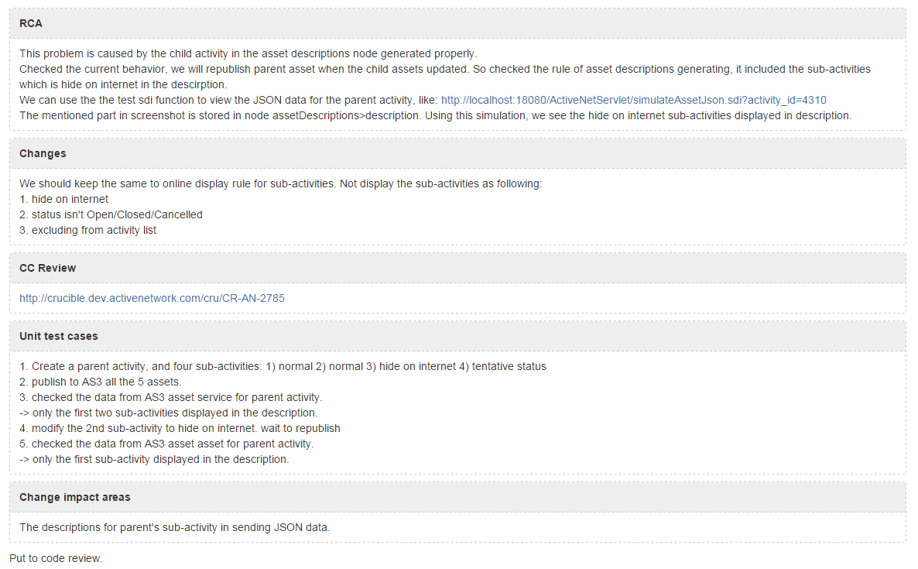

# Comment Source code:

*{panel:title=RCA\| borderStyle=dashed\| borderColor=#ccc\| titleBGColor=#eee \|bgColor=#FFF}*

*This problem is caused by the child activity in the asset descriptions node generated properly.*

*Checked the current behavior, we will republish parent asset when the child assets updated. So checked the rule of asset descriptions generating, it included the sub-activities which is hide on internet in the descirption.*

*We can use the the test sdi function to view the JSON data for the parent activity, like: http://localhost:18080/ActiveNetServlet/simulateAssetJson.sdi?activity_id=4310*

*The mentioned part in screenshot is stored in node assetDescriptions>description. Using this simulation, we see the hide on internet sub-activities displayed in description.*

*{panel}*

*{panel:title=Changes\| borderStyle=dashed\| borderColor=#ccc\| titleBGColor=#eee \|bgColor=#FFF}*

*We should keep the same to online display rule for sub-activities. Not display the sub-activities as following:*

*1. hide on internet*

*2. status isn't Open/Closed/Cancelled*

*3. excluding from activity list*

*{panel}*

*{panel:title=CC Review\| borderStyle=dashed\| borderColor=#ccc\| titleBGColor=#eee \|bgColor=#FFF}*

*http://crucible.dev.activenetwork.com/cru/CR-AN-2785*

*{panel}*

*{panel:title=Unit test cases\| borderStyle=dashed\| borderColor=#ccc\| titleBGColor=#eee \|bgColor=#FFF}*

*1. Create a parent activity, and four sub-activities: 1) normal 2) normal 3) hide on internet 4) tentative status*

*2. publish to AS3 all the 5 assets.*

*3. checked the data from AS3 asset service for parent activity.*

*-> only the first two sub-activities displayed in the description.*

*4. modify the 2nd sub-activity to hide on internet. wait to republish*

*5. checked the data from AS3 asset asset for parent activity.*

*-> only the first sub-activity displayed in the description.*

*{panel}*

*{panel:title=Change impact areas\| borderStyle=dashed\| borderColor=#ccc\| titleBGColor=#eee \|bgColor=#FFF}*

*The descriptions for parent's sub-activity in sending JSON data.*

*{panel}*

*Put to code review.*